**Python Assignment que 2**

**Write a program that prompts the user to input number of calls and calculate the monthly telephone bills as per the following rule:**

**Minimum Rs. 200 for up to 100 calls.**

**Plus Rs. 0.60 per call for next 50 calls.**

**Plus Rs. 0.50 per call for next 50 calls.**

**Plus Rs. 0.40 per call for any call beyond 200 calls.**

def cal_telephone_bill(no_of_calls):

base_charge = 200 # Minimum charge for up to 100 calls

cost_per_call_1 = 0.60 # Cost for the next 50 calls

cost_per_call_2 = 0.50 # Cost for the next 50 calls

cost_per_call_3 = 0.40 # Cost for any call beyond 200 calls

if no_of_calls <= 100:

total_cost = base_charge

elif no_of_calls>100 and no_of_calls <= 150:

total_cost = base_charge + (no_of_calls - 100) * cost_per_call_1

elif no_of_calls>150 and no_of_calls <= 200:

total_cost = base_charge + 50 * cost_per_call_1 + (no_of_calls - 150) * cost_per_call_2

else:

total_cost = base_charge + 50 * cost_per_call_1 + 50 * cost_per_call_2 + (no_of_calls - 200) * cost_per_call_3

return total_cost

if __name__ == "__main__":

no_of_calls = int(input("Enter the number of calls: "))

monthly_bill = cal_telephone_bill(no_of_calls)

print("Monthly Telephone Bill: Rs.", monthly_bill)

**OUTPUT:**

**1.Enter the number of calls: 100**

**Monthly Telephone Bill: Rs. 200**

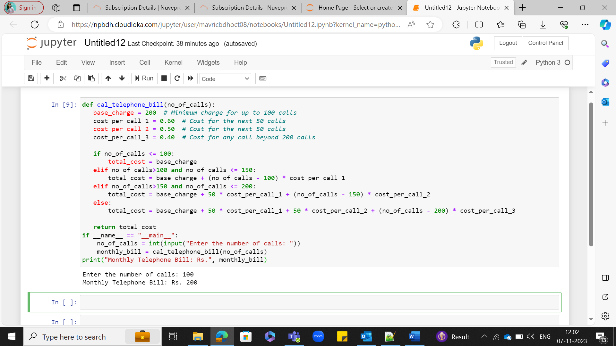

**2.Enter the number of calls: 149**

**Monthly Telephone Bill: Rs. 229.4**

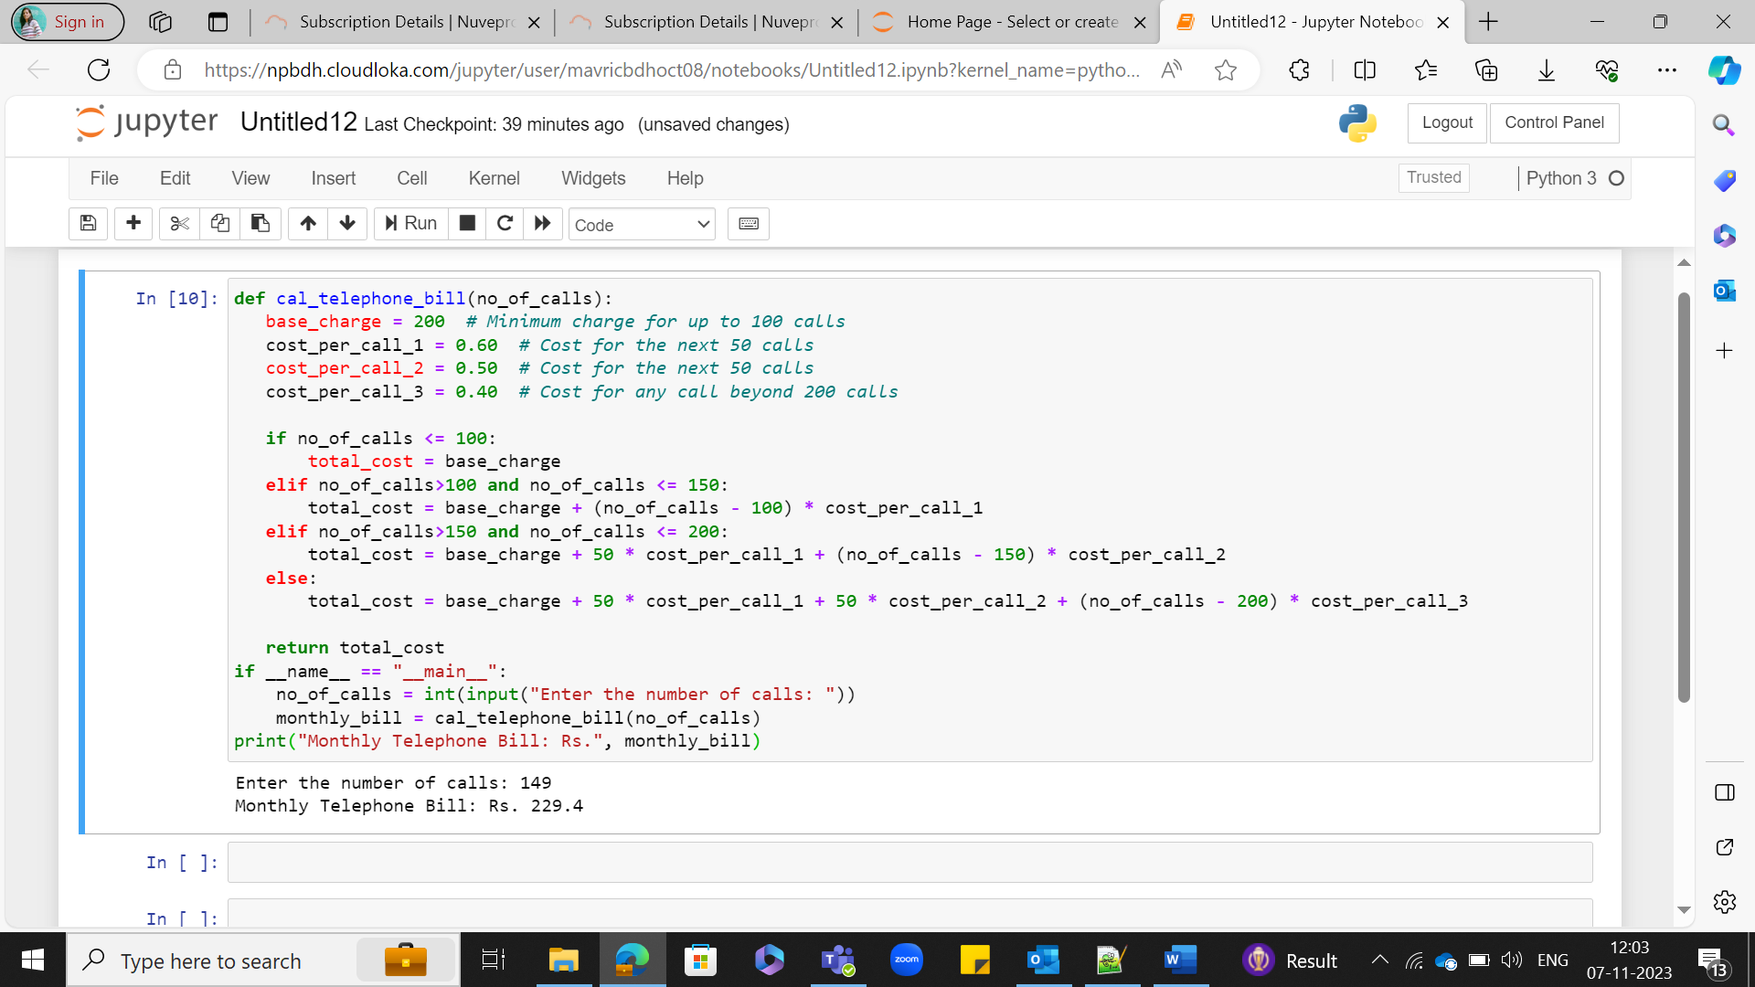

**3.Enter the number of calls: 200**

**Monthly Telephone Bill: Rs. 255.0**

**4.Enter the number of calls: 210**

**Monthly Telephone Bill: Rs. 259.0**

